To: Dr. Halil Berberoglu

From: Colin Murphy, Rachel Purvis, Andrew Sheu, Bryan Stockberger, Zach Straw

Date: 3/11/2011

Subject: Semester Project Phase One

Introduction

The cogeneration power plant currently in use by The University of Texas at Austin uses a Westinghouse Model 251B combustion turbine-generator to provide electricity and heating. The power plant is modeled after a Brayton Cycle, composed of an intercooler, compressor, combustor, turbine and a regenerator. The analysis of phase 1 of this project will only consider the compressor, combustor, and turbine parts of the cycle. The goal of this phase will be to provide a model that evaluates the performance of the turbine, by providing data concerning the thermal efficiency, fuel mass flow rate, specific fuel consumption, heat rate and firing temperature. Basic design parameters to be incorporated into the computer model include the composition of the working fluid, inlet pressure and temperature and volumetric flow rate, fuel type and heating value of the fuel. Parameters given by Westinghouse include compressor compression ratio, compressor efficiency, turbine efficiency and the generator efficiency. By performing the analysis, the effects of evaporative cooling and backpressure can be determined and used for future reference.

Procedure

In order to analyze the performance parameters of the system, the MATLAB code is designed with several assumptions. These assumptions include that the cycle is an air-standard Brayton Cycle, the air flowing through the system is a temperature-dependent ideal gas with a reference temperature of 25⁰C and a reference pressure of 1 atmosphere, and that the air is pure with a composition of 21% O2 and 79% N2 and a relative humidity of 0%.

After taking account all of these assumptions, the Rmix and the Mmix of the air were obtained in order to find the T3s and T3A of the compressor. T3s was calculated by assuming constant entropy (Equation 3) and using the isentropic entropy relation for an ideal gas (Equation 3). Temperatures and pressures at these states can be found in the tables of the appendix (Table 1, Table 2, Table 3, Table4). T3 is then calculated using the compressor efficiency (Equation 5). After finding this temperature, ṁ is needed in order to obtain compressor power and calculated using the ideal gas law given $\dot{V}$ (Equation 12). Power for the compressor is then obtained (Equation 7).

The approach to find the mass flow rate of the fuel entering the combustor involves an iterative approach, whereby choosing values of the mass flow and incrementing them until the known power output of the system is reached. From here, the Lower Heating Value is multiplied by this flow rate to obtain the heat addition per rate basis to the combustor. Using T3A and tables 6s-7s from *Schmidt et. al*, h3 can be calculated and applied to the given molar fractions for each constituent species (Table 1, Table 2). By performing an energy balance, taking the control volume as the combustor, enthalpy h4 was calculated (Equation 16). To get T4 from h4, integration of the enthalpy and the specific heat from the reference state of 298K to state 4 was performed (Equation 13).

After finding the properties at state 4, T5 was determined using the same process as that of finding T3 from T2, which is described as above using Equation 3; substituting states 4 for 2 and 5 for 3. Obtaining h5 from T5 requires referencing tables 6s -7s from *Schmidt et. al* and applying these values to the given molar fractions for each constituent species(Table 1, Table 2).

With all these temperature values, the compressor and the turbine work outputs were readily obtained (Equations 7 and 8) to calculate the net mechanical work output of the system (Equation 14). Then the generator efficiency was used to calculate the net electrical work output of the system (Equation 9). The net electrical work output value was then used with the given heat input to find the overall thermal efficiency of the cycle (Equation 11).

The heat rate was determined by using the given electrical heat input and the net electrical work output (Equation 10). It is important that the unit for the heat is equivalent to Btu/kW-hr. Lastly, the specific fuel consumption was evaluated by dividing the fuel flow rate over the net power input to the cycle (Equation 15).

Results and Discussion

It was observed that as the percent load increases, the thermal efficiency increases as well (Figure 1). This trend is valid because from Equation 11, it can be seen that as the net power output is increased the efficiency will follow the same pattern. However, after a certain percent load, it should be noted that the increase in efficiency becomes smaller and eventually reaches a maximum. When observing the fuel flow rate compared to the percent load, a linear trend was seen, suggesting that increasing the load will directly increase the fuel flow demand (Figure 2). Looking at Specific Fuel Consumption, it can be stated that there was a sharp decline after 30% of the load was inputted into the system (Figure 3). Running this system between 20% and 30% will yield poor fuel consumption. Thus, running the system above 30% is preferred to minimize the amount of fuel consumed. Comparing load to heat rate of the system, it can be stated that operating closer the maximum load percentage will lower the heat rate to the combustor (Figure 4). Thus, a lower heat rate will produce a more efficient system and higher net work output. By increasing the percent load, the firing temperature will directly increase and suggests that for more power output, a higher inlet temperature to the turbine is necessary(Figure 5, Figure 6). The temperatures were found to decrease with increase in percent load and the pressures remained the same with increases in percent load (Table 1, Table 2, Table 3, Table 4).

Conclusion

This project has taught us how to use MATLAB to simulate the various processes of an air standard Brayton Cycle. We evaluated the effect that varying the fuel flow rate entering the combustor had on various thermodynamic properties, and how these changes altered the performance of the Brayton Cycle as a whole. These changes allowed us to see what parameters resulted in the most efficient system possible given our inputs.

Appendix

References:

Schmidt, Philip S. *Thermodynamics: an Integrated Learning System.* Hoboken, NJ: Wiley, 2004. Print.

Equations

$R_{mix}=\frac{\overline{R}}{M_{mix}}$

$M_{mix}=\sum{y_{i}}M_{i}$

$∆s_{2→3}=\int_{T_{2}}^{T_{3_{s}}}{c_{P}\left(T\right)\frac{dT}{T}}-Rln\left(\frac{P_{3}}{P_{2}}\right)=0$

$\dot{m}=\frac{\dot{Q}}{LHV}$

$η_{c}=\frac{T_{3_{s}}-T_{2}}{T_{3_{A}}-T_{2}}$

$η_{T}=\frac{T_{4}-T_{5_{A}}}{T_{4}-T_{5_{s}}}$

${\dot{W}}_{C}= \dot{m}\left(h_{3_{A}}-h_{2}\right)$

$\dot{W_{T}}=\dot{m}\left({h_{4}-h}_{5_{A}}\right)$

${\dot{W}}_{{NET}_{E}}={\dot{W}}_{NET}η_{GENERATOR}$

$Heat Rate=\frac{{\dot{Q}}_{IN}}{{\dot{W}}_{{NET}_{E}}}$

$η_{TH}= \frac{{\dot{W}}_{t}-\dot{W_{C}}}{{\dot{Q}}_{IN}}$

$P\dot{V}=\dot{m}RT$

$\int_{h_{ref}}^{h}{dh= \int_{T_{ref}}^{T}{CpdT}}$

${\dot{W}}_{NET}= {\dot{W}}_{T}-{\dot{W}}_{C}$

$Specific Fuel Consumption=\frac{{\dot{m}}_{F}}{W_{NET}}$

$h_{4}=\frac{{\dot{m}}_{a}*h_{3}+{\dot{m}}_{f}*LHV}{{\dot{m}}_{a}}$

Figures:

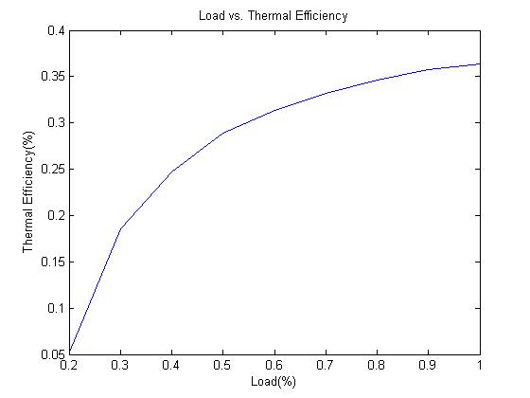

Figure 1: Thermal efficiency *ηTH* vs. percentage of full load

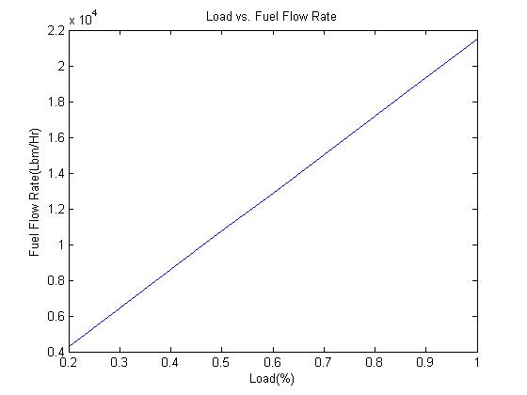

Figure 2: Fuel mass flow rate *ṁ* [lbm/hr] vs. percentage of full load

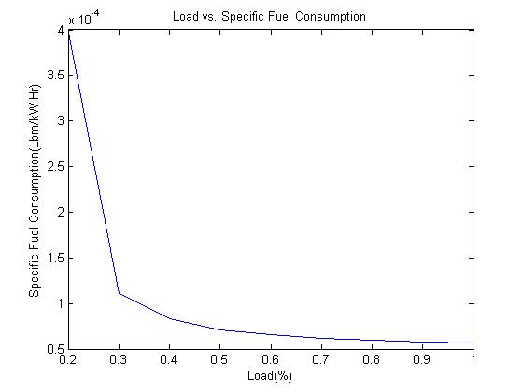

Figure 3: Specific fuel consumption: SFC [lbm/kW-hr] vs. percentage of full load

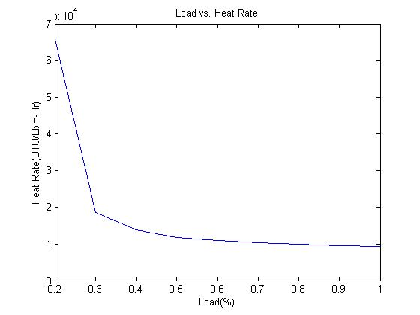

Figure 4: Heat rate: HR [BTU/kW-hr] vs. percentage of full load

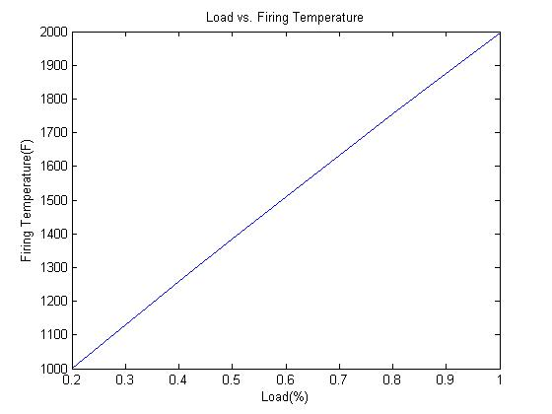

Figure 5: Firing (turbine inlet) temperature: T4 [°F] vs. percentage of full load

Table 1: % load versus temperature at each thermodynamic station

|  |  |  |  |  |  |  |  |  |  |
| --- | --- | --- | --- | --- | --- | --- | --- | --- | --- |
| Temperature(°F) of Each State | | | | | | | | | |
| Percent Load | 1.00 | 0.90 | 0.80 | 0.70 | 0.60 | 0.50 | 0.40 | 0.30 | 0.20 |
| State2 | 59.00 | 59.00 | 59.00 | 59.00 | 59.00 | 59.00 | 59.00 | 59.00 | 59.00 |
| State3 | 733.97 | 733.97 | 733.97 | 733.97 | 733.97 | 733.97 | 733.97 | 733.97 | 733.97 |
| State4 | 1996.28 | 1875.46 | 1754.65 | 1633.83 | 1508.85 | 1383.87 | 1258.89 | 1129.74 | 1000.59 |
| State5 | 927.10 | 851.68 | 778.74 | 705.49 | 630.80 | 554.80 | 480.92 | 403.16 | 327.74 |

Table 2: % load versus temperature at each thermodynamic station

|  |  |  |  |  |  |  |  |  |  |
| --- | --- | --- | --- | --- | --- | --- | --- | --- | --- |
|  | Temperature(K) of Each State | | | | | | | | |
| Percent Load | 1.00 | 0.90 | 0.80 | 0.70 | 0.60 | 0.50 | 0.40 | 0.30 | 0.20 |
| State2 | 288.33 | 288.33 | 288.33 | 288.33 | 288.33 | 288.33 | 288.33 | 288.33 | 288.33 |
| State3 | 663.31 | 663.31 | 663.31 | 663.31 | 663.31 | 663.31 | 663.31 | 663.31 | 663.31 |
| State4 | 1364.60 | 1297.48 | 1230.36 | 1163.24 | 1093.81 | 1024.37 | 954.94 | 883.19 | 811.44 |
| State5 | 770.61 | 728.71 | 688.19 | 647.49 | 606.00 | 563.78 | 522.73 | 479.53 | 437.63 |

Table 3: % load of versus pressure at each thermodynamic station

|  |  |  |  |  |  |  |  |  |  |
| --- | --- | --- | --- | --- | --- | --- | --- | --- | --- |
| Pressure (psia) of Each State | | | | | | | | | |
| Percent Load | 1.00 | 0.90 | 0.80 | 0.70 | 0.60 | 0.50 | 0.40 | 0.30 | 0.20 |
| State2 | 14.70 | 14.70 | 14.70 | 14.70 | 14.70 | 14.70 | 14.70 | 14.70 | 14.70 |
| State3 | 220.50 | 220.50 | 220.50 | 220.50 | 220.50 | 220.50 | 220.50 | 220.50 | 220.50 |
| State4 | 220.50 | 220.50 | 220.50 | 220.50 | 220.50 | 220.50 | 220.50 | 220.50 | 220.50 |
| State5 | 14.70 | 14.70 | 14.70 | 14.70 | 14.70 | 14.70 | 14.70 | 14.70 | 14.70 |

Table 4: % load versus pressure at each thermodynamic station

|  |  |  |  |  |  |  |  |  |  |
| --- | --- | --- | --- | --- | --- | --- | --- | --- | --- |
|  | Pressure (kPa) of Each State | | | | | | | | |
| Percent Load | 1.00 | 0.90 | 0.80 | 0.70 | 0.60 | 0.50 | 0.40 | 0.30 | 0.20 |
| State2 | 2.13 | 2.13 | 2.13 | 2.13 | 2.13 | 2.13 | 2.13 | 2.13 | 2.13 |
| State3 | 31.98 | 31.98 | 31.98 | 31.98 | 31.98 | 31.98 | 31.98 | 31.98 | 31.98 |
| State4 | 31.98 | 31.98 | 31.98 | 31.98 | 31.98 | 31.98 | 31.98 | 31.98 | 31.98 |
| State5 | 2.13 | 2.13 | 2.13 | 2.13 | 2.13 | 2.13 | 2.13 | 2.13 | 2.13 |

Matlab Code:

**MAIN PROGRAM**

clear all;

global RH RMIX R Y X MMIX;

RH=0;

Y=[0 0 0.21 0.79 RH 0];

M=[4.003 39.948 31.999 28.013 18.015 44.010]; %[He Ar O2 N2 H2O CO2]

R=[2.077 .208 .26 .297 .462 .189];

MMIX=M*Y';%Calculate other mixture values

X=Y.*M./MMIX;

RMIX=8.3145/MMIX;

Rv=15;

Ncomp=.866; Nturb=.885; Ngen=.985;

Vdotft3=290000;%ft^3/m

VdotAir=Vdotft3*.028317/60;%m^3/s

MdotAir=(14.7/.14504)*VdotAir/(RMIX*(5/9*(68+460)));%kg/s

LHVBTU=20960;%BTU/lbm

LHV=LHVBTU*1.055*2.2046;%kj/kg

MdotFuelLbm(1)=10000;

Load=[1 .9 .8 .7 .6 .5 .4 .3 .2];

for k=1:9

delWcycle(1)=10;

j=1;

MFa=0;

MFb=100000;

MdotFuelLbm(k)=Load(k)*MdotFuelLbm(1);

while(abs(delWcycle(j))>=.01) & (j<100)

if k==1

MdotFuelLbm(k)=(MFa+MFb)/2;

end

MdotFuel=MdotFuelLbm(k)*.45359/3600;%kg/s

%State 2

T2=59; P2(k)=14.7;

Temp2(k)=T2;

STATE2=values([T2 P2]);

K2=STATE2(4);

h2=STATE2(1);

%State 3

P3=Rv*P2;

%Iterate to find value of T4

T3sa=T2;

T3sb=1000;

i=1;

deltaS(1)=1;

while(abs(deltaS(i))>=.001) & (i<10)

T3s=(T3sa+T3sb)/2;

STATE3s=values([T3s P3(k)]);

deltaS(i+1)=(STATE3s(3)-STATE2(3))-RMIX*log(Rv);

if (deltaS(i+1) >= 0)

T3sb=T3s;

elseif (deltaS(i+1) < 0)

T3sa=T3s;

end

i=i+1;

end%Final T3s value is T3 in the isentropic case

h3s=STATE3s(1);

%Iterate to find actual T3 with isentropic efficiency

deltaH(1)=10;

i=1;

T3a=T3s;

T3b=1000;

while(abs(deltaH(i))>=1) & (i<10)

T3=(T3a+T3b)/2;

STATE3=values([T3 P3(k)]);

h3=STATE3(1);

deltaH(i+1)=Ncomp*(h3-h2)-(h3s-h2);

if (deltaH(i+1) >= 0)

T3b=T3;

elseif (deltaH(i+1) < 0)

T3a=T3;

end

i=i+1;

end

h3=STATE3(1);

Temp3(k)=T3;

%State 4

P4=P3;

h4=(h3*MdotAir+MdotFuel*LHV)/MdotAir;

deltaH(1)=10;

i=1;

T4a=T3;

T4b=5000;

while(abs(deltaH(i))>=1) & (i<100)

T4=(T4b+T4a)/2;

STATE4=values([T4 P4]);

deltaH(i+1)=STATE4(1)-h4;

if (deltaH(i+1) >= 0)

T4b=T4;

elseif (deltaH(i+1) < 0)

T4a=T4;

end

i=i+1;

end

Temp4(k)=T4;

%State 5

P5=P2;

T5sa=T4;

T5sb=0;

i=1;

deltaS(1)=1;

while(abs(deltaS(i))>=.001) & (i<10)

T5s=(T5sa+T5sb)/2;

STATE5s=values([T5s P5]);

deltaS(i+1)=(STATE5s(3)-STATE4(3))-RMIX*log(1/Rv);

if (deltaS(i+1) >= 0)

T5sa=T5s;

elseif (deltaS(i+1) < 0)

T5sb=T5s;

end

i=i+1;

end%Final T5s value is T5 in the isentropic case

h5s=STATE5s(1);

deltaH(1)=10;

i=1;

T5a=T5s;

T5b=T4;

while(abs(deltaH(i))>=1) & (i<100)

T5=(T5a+T5b)/2;

STATE5=values([T5 P3]);

h5=STATE5(1);

deltaH(i+1)=Nturb*(h5s-h4)-(h5-h4);

if (deltaH(i+1) >= 0)

T5a=T5;

elseif (deltaH(i+1) < 0)

T5b=T5;

end

i=i+1;

end

h5=STATE5(1);

Temp5(k)=T5;

WTurbine=MdotAir*(h4-h5);

WCompressor=MdotAir*(h3-h2);

Wcycle(k)=(WTurbine-WCompressor)*Ngen;

delWcycle(j+1)=Wcycle(k)-48000;

if (delWcycle(j+1) >= 0) & (k==1)

MFb=MdotFuelLbm;

elseif (delWcycle(j+1) < 0) & (k==1)

MFa=MdotFuelLbm;

else

delWcycle(j+1)=0;

end

j=j+1;

end

WTurbine=MdotAir*(h4-h5);

WCompressor=MdotAir*(h3-h2);

Wcycle(k)=(WTurbine-WCompressor)*Ngen;

Nthermal(k)=Wcycle(k)/(MdotFuel*LHV);

SFC(k)=MdotFuel/Wcycle(k);

HeatRate(k)=(MdotFuelLbm(k)*LHVBTU)/Wcycle(k);

FiringTempF(k)=T4;

FiringTempK(k)=(T4+460)*5/9;

end

figure(1);

plot(Load,Nthermal);

title('Load vs. Thermal Efficiency')

xlabel('Load(%)')

ylabel('Thermal Efficiency(%)')

figure(2);

plot(Load,MdotFuelLbm);

title('Load vs. Fuel Flow Rate')

xlabel('Load(%)')

ylabel('Fuel Flow Rate(Lbm/Hr)')

figure(3);

plot(Load,SFC);

title('Load vs. Specific Fuel Consumption')

xlabel('Load(%)')

ylabel('Specific Fuel Consumption(Lbm/kW-Hr)')

figure(4);

plot(Load,HeatRate);

title('Load vs. Heat Rate')

xlabel('Load(%)')

ylabel('Heat Rate(BTU/Lbm-Hr)')

figure(5);

plot(Load,FiringTempF);

title('Load vs. Firing Temperature')

xlabel('Load(%)')

ylabel('Firing Temperature(F)')

figure(6);

plot(Load,FiringTempK);

title('Load vs. Firing Temperature')

xlabel('Load(%)')

ylabel('Firing Temperature(K)')

TEMPS=[Temp2;Temp3;Temp4;Temp5];

PRESS=[P2;P3;P4;P5];

**FUNCTION ‘values’**

function y = values(x)%input parameter = [temp(F) pressure(psiA)]

%Stored reference values

global RH RMIX R Y X MMIX;

Sref=[31.5375 3.876 6.6999 6.8045 10.423 4.8585];

Uref=[928.419 92.976 194.2 221.44 412.05 156.57];

Href=[1547.365 154.96 271.72 309.99 549.75 212.93];

%Tabulated Cp and Cv values from table 5s

Cp5s=[1.0041 1.0107 1.0249 1.0452 1.0687 1.0927 1.1154 1.1360 1.1544 1.1706 1.1848 1.1973 1.2083 1.2180 1.2267 1.2345 1.2416 1.2480 1.2539 1.2593 1.2644];

Cv5s=[.7169 .7235 .7376 .758 .7815 .8054 .8281 .8488 .8672 .8834 .8976 .9101 .9210 .9308 .9395 .9473 .9544 .9608 .9667 .9721 .9771];

Pref=100;%in kPa

Tref=298;%in Kelvin

COEFF=[0 0 0 0;%Coefficients of Cp equations

0 0 0 0;

0.7963 4.7501e-004 -2.2360e-007 4.1001e-011;

1.0317 -5.6081e-005 2.8847e-007 -1.0256e-010;

1.7896 1.0674e-004 5.8562e-007 -1.9956e-010;

0.5058 0.0014 7.9550e-007 1.6971e-010];

CvCOEFF=COEFF;%Coefficients of Cv equations where Cv=Cp-R

CvCOEFF(3,1)=COEFF(3,1)-R(3);

CvCOEFF(4,1)=COEFF(4,1)-R(3);

CvCOEFF(5,1)=COEFF(5,1)-R(3);

CvCOEFF(6,1)=COEFF(6,1)-R(3);

sintCOEFF(:,1)=COEFF(:,1);%Divide each coefficient by its respective power for integration to find entropy

sintCOEFF(:,2)=COEFF(:,2);

sintCOEFF(:,3)=COEFF(:,3)/2;

sintCOEFF(:,4)=COEFF(:,4)/3;

intCOEFF(:,1)=COEFF(:,1);%Divide each coefficient by its respective power for integration to find h

intCOEFF(:,2)=COEFF(:,2)/2;

intCOEFF(:,3)=COEFF(:,3)/3;

intCOEFF(:,4)=COEFF(:,4)/4;

intCvCOEFF(:,1)=CvCOEFF(:,1);%Divide each coefficient by its respective power for integration to find u

intCvCOEFF(:,2)=CvCOEFF(:,2)/2;

intCvCOEFF(:,3)=CvCOEFF(:,3)/3;

intCvCOEFF(:,4)=CvCOEFF(:,4)/4;

hrefMIX=Href*X';

urefMIX=Uref*X';

srefMIX=Sref*X';

%get values of mixture pressure and temperature

%disp 'Input the mixture Pressure(kPa) and Temperature(C):';

pressPSIA=x(2);%input('Pressure(PsiA): ');

pressKPA=pressPSIA/.14504;

tempF=x(1);%input('Temperature(F): ');

tempK=5/9*(tempF+460);%Temperature F to K;

intCpMIXref=303.6432;%Constant integrated value of Cp at reference temperature (298K)

intCvMIXref=226.1387;%Constant integrated value of Cv at reference temperature (298K)

sMIXref=5.5924;%Constant integrated value of Cpdt/T at reference temperature (298K)

TEMPz=[tempK 298];

%calculate values of Cp and Cv, integrals of Cp and Cv, h, u and s

for i=1:2

temp=TEMPz(i);

TEMP=[1 temp temp^2 temp^3];

sTEMP=[log(temp) temp temp^2 temp^3];

Cp=COEFF*TEMP';

Cp(1)=5/2*R(1);

Cp(2)=5/2*R(2);

Cp=COEFF*TEMP';

s=sintCOEFF*sTEMP';

s(1)=5/2*R(1)*log(temp);

s(2)=5/2*R(2)*log(temp);

intTEMP=temp*TEMP;%Add a power to each temp

intCp=intCOEFF*intTEMP';%Calculate integral values for 4 polynomial functions

intCp(1)=5/2*R(1)*temp;%Assign integrated values of constant 5/2*R values = 5/2*R*temp

intCp(2)=5/2*R(2)*temp;

intCv=intCvCOEFF*intTEMP';

intCv(1)=3/2*R(1)*temp;

intCv(2)=3/2*R(2)*temp;

CpMIXA=X*Cp;%multiply matrices to calculate values

intCpMIXA(i)=X*intCp;

intCvMIXA(i)=X*intCv;

CvMIXA=CpMIXA-RMIX;

sMIX(i)=X*s;

i=i+1;

end

h=intCpMIXA(1)-intCpMIXA(2)+hrefMIX;

u=intCvMIXA(1)-intCvMIXA(2)+urefMIX;

S=sMIX(1)-sMIX(2)+srefMIX;%-RMIX*log(pressKPA/Pref);

%Calculate other values

CpMIX=X*Cp;

CvMIX=RMIX-CpMIX;

K=CpMIX/CvMIX;

y=[h u S K];